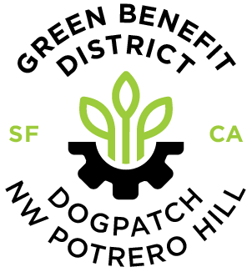

Dogpatch & NW Potrero Hill Green Benefit District
2015-2022 Summary

Area: 200 Acres/70 blocks in 2 zones
Chartered: by the Board of Supervisors in July, 2015
Assessment Base: 1702 Properties, 1358 property owners.
Governance: 15-Member, elected board of directors

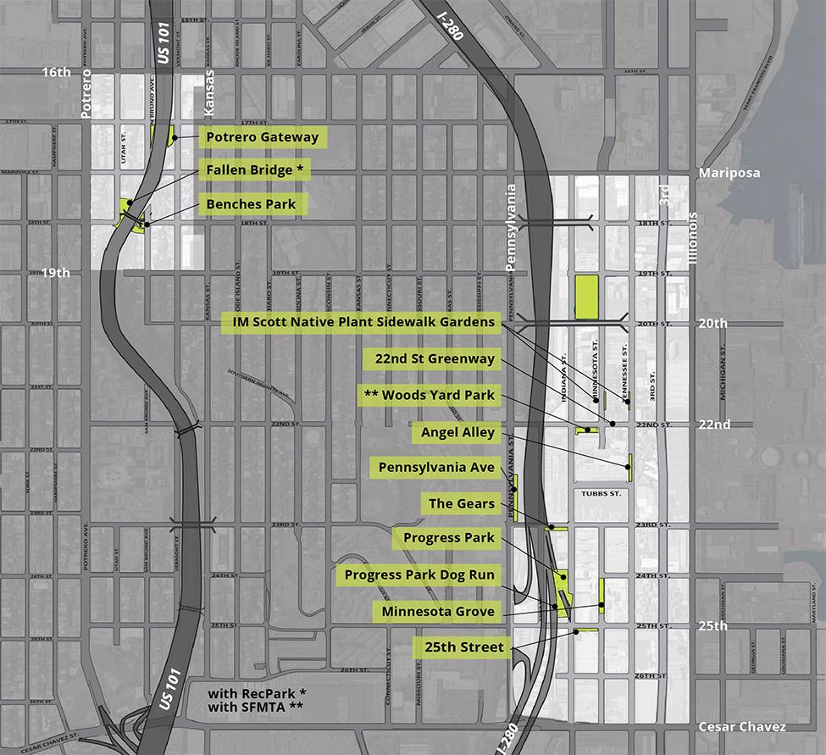
A Sample of GBD Parks & Greenspaces

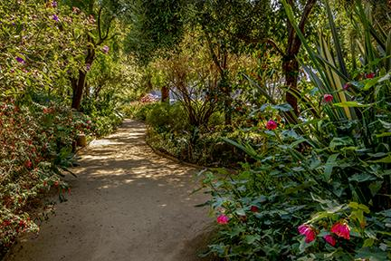 |  | 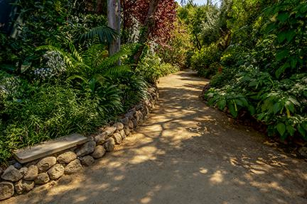
Minnesota Grove

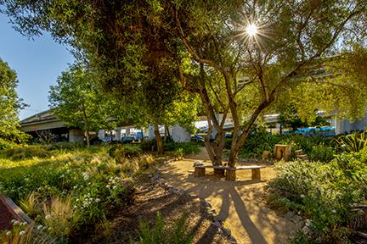 |  | 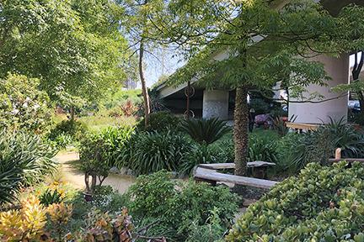
Progress Park

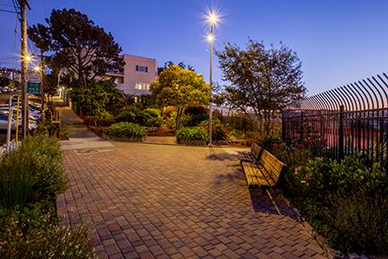 |  | 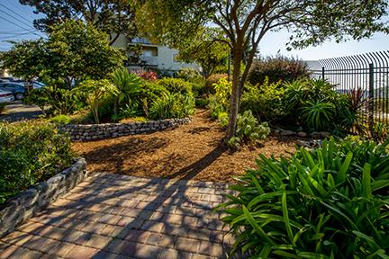
Benches Garden
A Sample of GBD Parks & Greenspaces

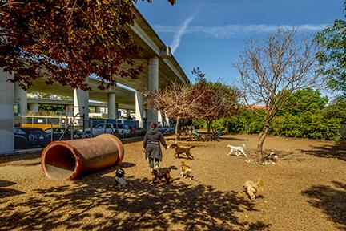 |  | 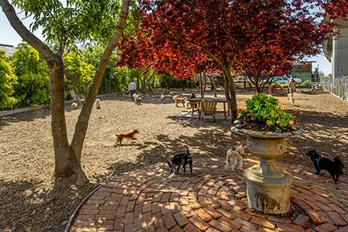
Progress Park Dog Run

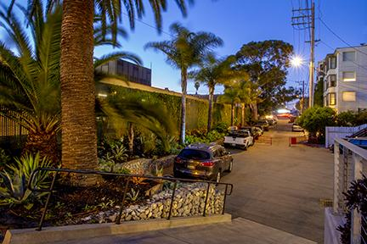 |  | 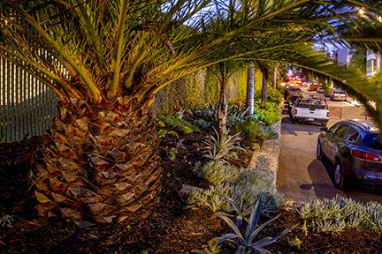
Angel Alley

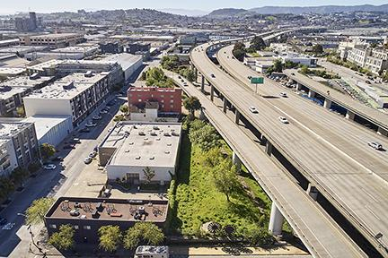 |  | 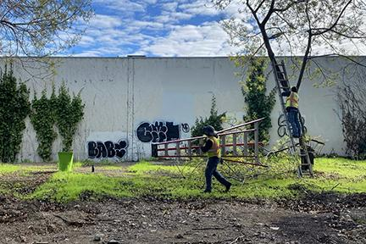
The Gears Meadow
Project highlights over 7 years

2015/16

In its first year, the GBD registered as a 501(c)(3); held board elections; contracted for landscaping and streetscape maintenance services; and hired an Executive Director.

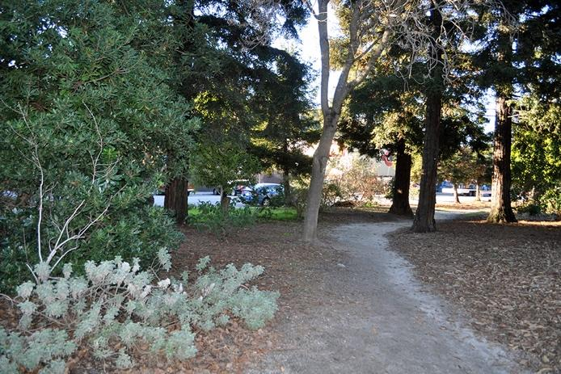 |  | 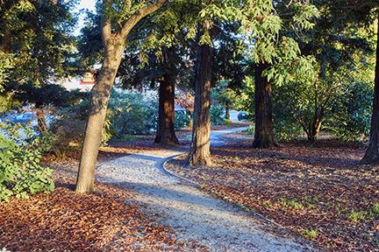
Regraded and resurfaced the west pedestrian path in Esprit Park (before/after)

2016/17

In its second year, the GBD strengthened outreach to the community; began applying for grants and soliciting donations; started developing a long-term pipeline of capital projects.

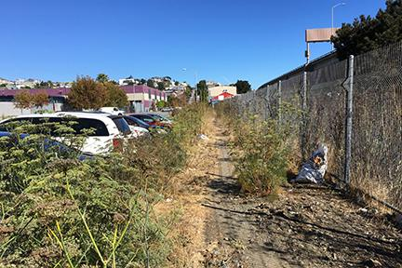 |  | 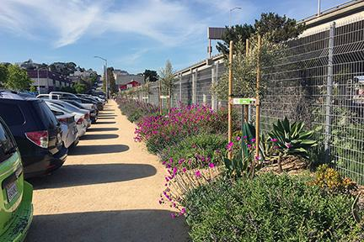
Converted a weedy dumping area on Pennsylvania Ave to a dry garden with path (before/after)

2017/18

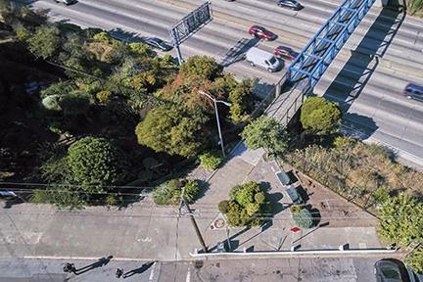 |  | 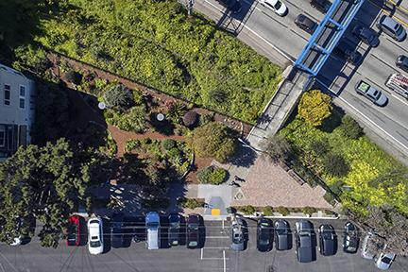
Improved Benches Garden and enlarged the adjacent 1970s plaza (before/after)

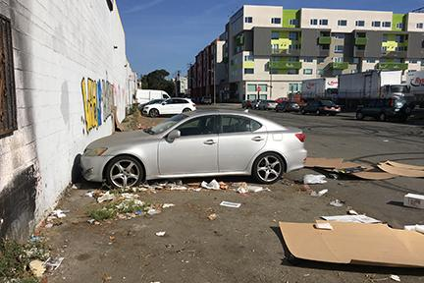 |  | 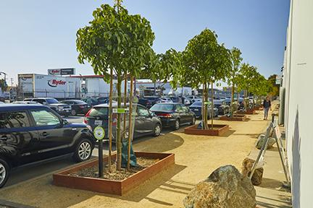
Reconfigured pathways, parking and planted 28 street trees on Tennessee St at 23rd (before/after)

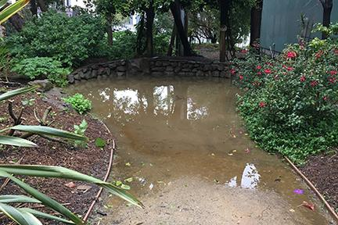
Extended Minnesota Grove’s walking path through the north end of the park (before/after)
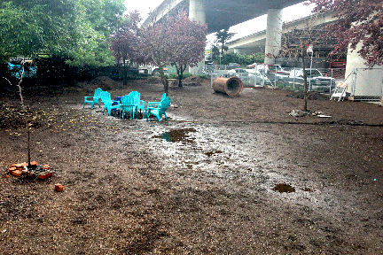 |  | 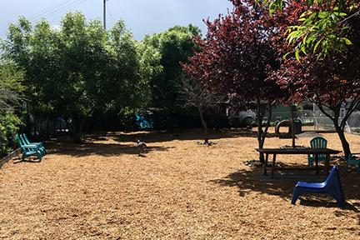
Improved drainage and landscaping at the Progress Park Dog Run (before/after)

2018/19

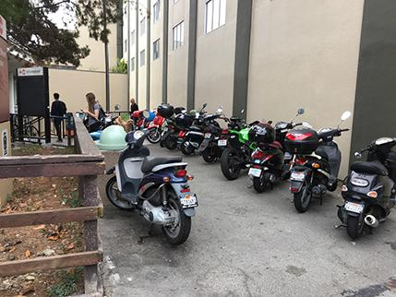 |  | 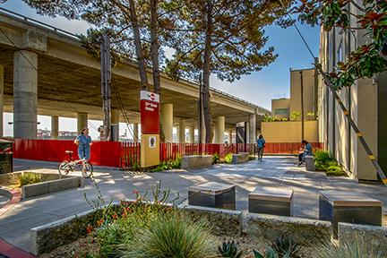
Upgraded the entrance to the 22nd St Caltrain Station entrance (before/after)

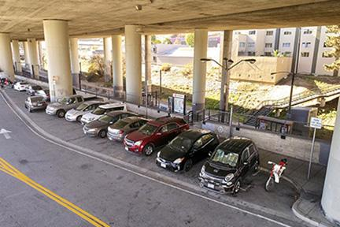 |  | 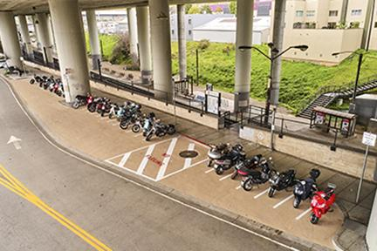
Created alt-vehicle parking at the Caltrain train station and commercial center (before/after)
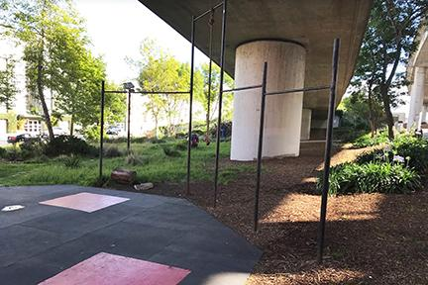 |  | 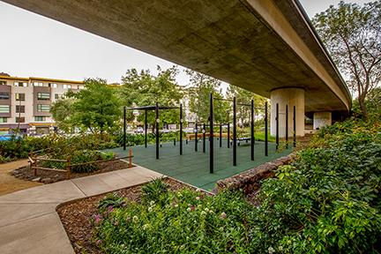
Upgraded the fitness equipment at Progress Park (before/after)

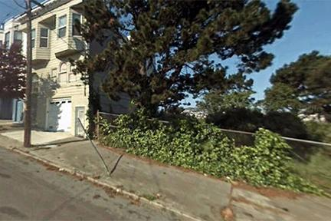 |  | 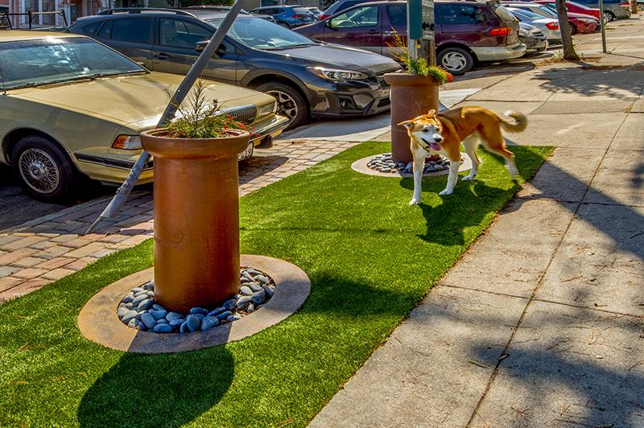
Experimented with Dog Station #1, near Benches park (before/after)

2018/19

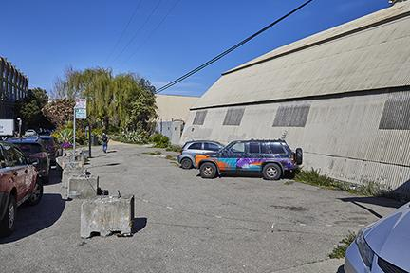 |  | 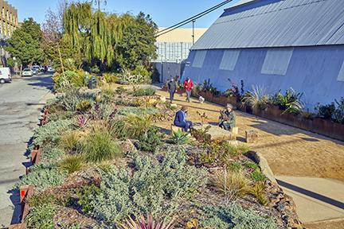
Increased Minnesota Grove by 50%, converting asphalt to permeable, planted area (before/after)
2020/21

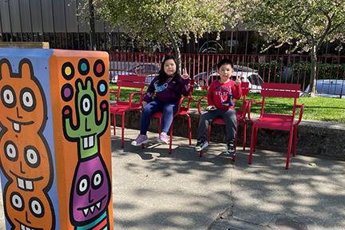 |  | 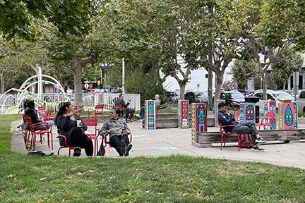
Added movable seating to Woods Yard Park

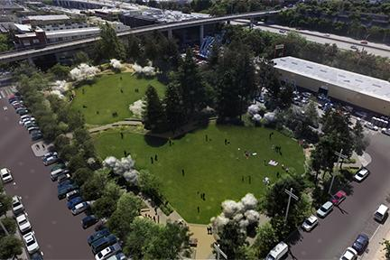 |  | 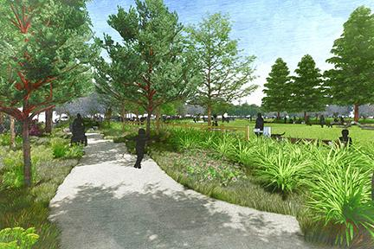
Managing the funding for the design and engineering phase of the Esprit Park Renovation

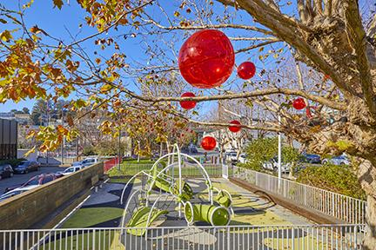 |  | 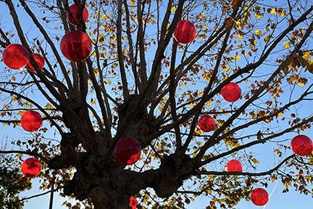
Sparked joy to the neighborhood during shutdown by decorating for the winter holidays.

2021/22

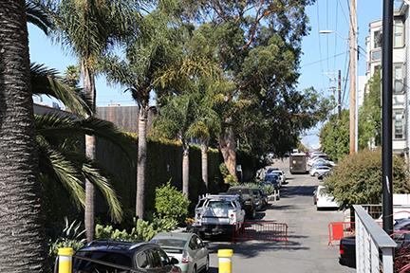 |  | 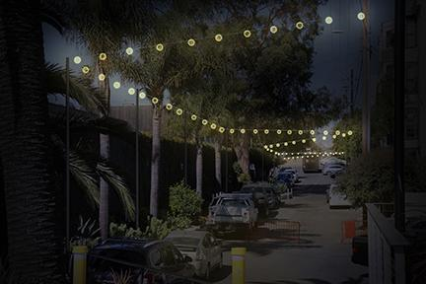
Installed catenary street lighting on Angel Alley
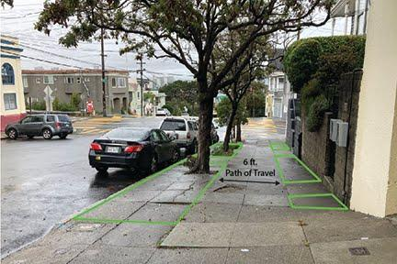 |  | 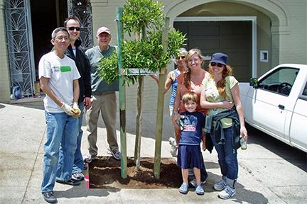
Partnered with Friends of the Urban Forest on tree planting and sidewalk gardens along Vermont St

2021/22

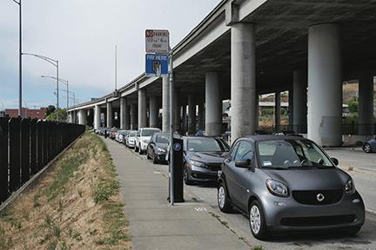 |  | 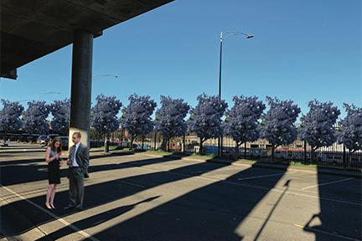
Creation of a sidewalk habitat garden near the Caltrain station and the 22nd St commercial corridor

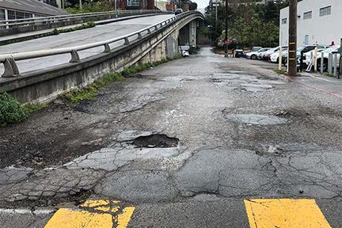 |  | 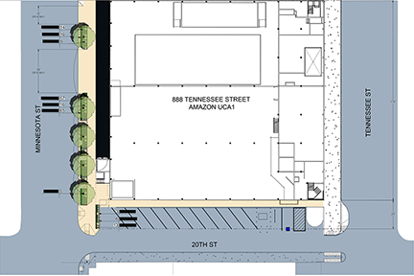
Addition of a sidewalk on an unaccepted portion of 20th St (installed by Amazon)

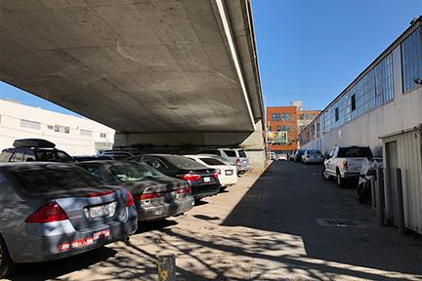 |  | 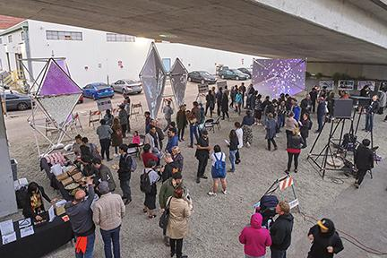
Conversion of an area under the 20th St overpass to public use

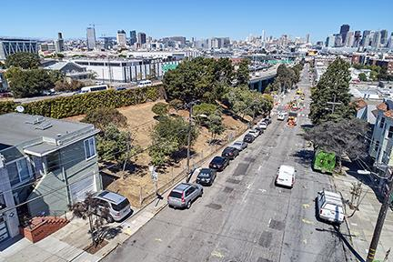 |  | 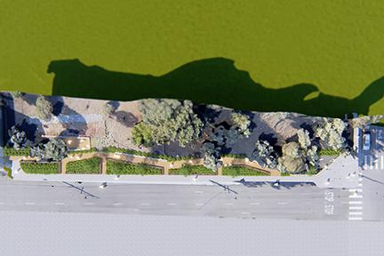
Closure of the west lane of Vermont St at the 101 exit and creation of a sidewalk garden

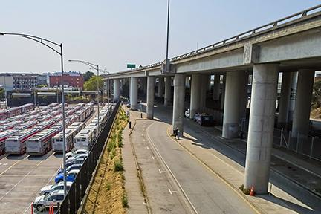 |  | 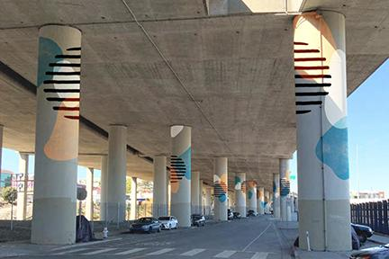
Pursuing funding for painting of the HWY 280 pylons along Iowa St

METRICS 2015-21

CAPITAL
Concrete and asphalt removed and planted (sq.ft.) 19,200
Parks & Greenspace added (sq.ft.) 12,800
Parks & Greenspace maintained (sq.ft.) 110,000
Pedestrian paths/temp sidewalks added (sq.ft.) 5,800

MAINTENANCE
In the four years between July 2017 and June 2021, GBD auxiliary care of the district includes:
Trash Removed (lbs) 198,200
Compost removed (lbs) 152,375
Needles collected 3,508
Graffiti sites cleaned 743
311 Reports filed 834
Volunteer hours 6,811
In addition, the GBD has assumed maintenance responsibilities for Public Works street tree and garden care on 4 blocks on 22nd St.
We will also care for 1.5 blocks of new street trees on 23rd and Minnesota Streets.

